In [1]:

**import** pandas **as** pd

**import** numpy **as** np

**import** matplotlib.pyplot **as** plt

**import** seaborn **as** sns

dataset **=** sns.load_dataset('titanic') dataset.head()

|  |  |  |  |  |  |  |  |  |  |  |  |  |  |  |
| --- | --- | --- | --- | --- | --- | --- | --- | --- | --- | --- | --- | --- | --- | --- |
| Out[1]: |  | | | | | | | | | | | | | |
|  |  | **survived** | **pclass** | **sex** | **age** | **sibsp** | **parch** | **fare** | **embarked** | **class** | **who** | **adult_male** | **deck** | **emb** |
|  | 0 | 0 | 3 | male | 22.0 | 1 | 0 | 7.2500 | S | Third | man | True | NaN | Sou |
|  | 1 | 1 | 1 | female | 38.0 | 1 | 0 | 71.2833 | C | First | woman | False | C | C |
|  | 2 | 1 | 3 | female | 26.0 | 0 | 0 | 7.9250 | S | Third | woman | False | NaN | Sou |
|  | 3 | 1 | 1 | female | 35.0 | 1 | 0 | 53.1000 | S | First | woman | False | C | Sou |
|  | 4 | 0 | 3 | male | 35.0 | 0 | 0 | 8.0500 | S | Third | man | True | NaN | Sou |

In [2]:

sns.boxplot(x**=**'sex', y**=**'age', data**=**dataset)

Out[2]: <matplotlib.axes._subplots.AxesSubplot at 0x1527f09c1c8>

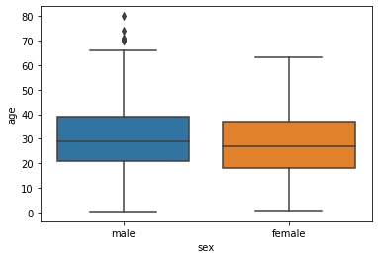

In [3]:

sns.boxplot(x**=**'sex', y**=**'age', data**=**dataset, hue**=**"survived")

Out[3]: <matplotlib.axes._subplots.AxesSubplot at 0x1527f3dcec8>

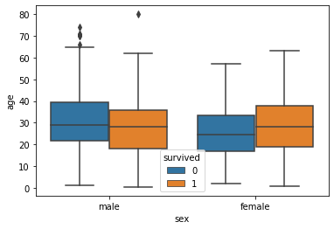

In [ ]: